Table Joins  
DAD 220 Intro to Struct Database Env

Sergio Mateos

Southern New Hampshire University

1. Text

   Description automatically generatedStart SQL
2. Update the name of the Branches table.

* 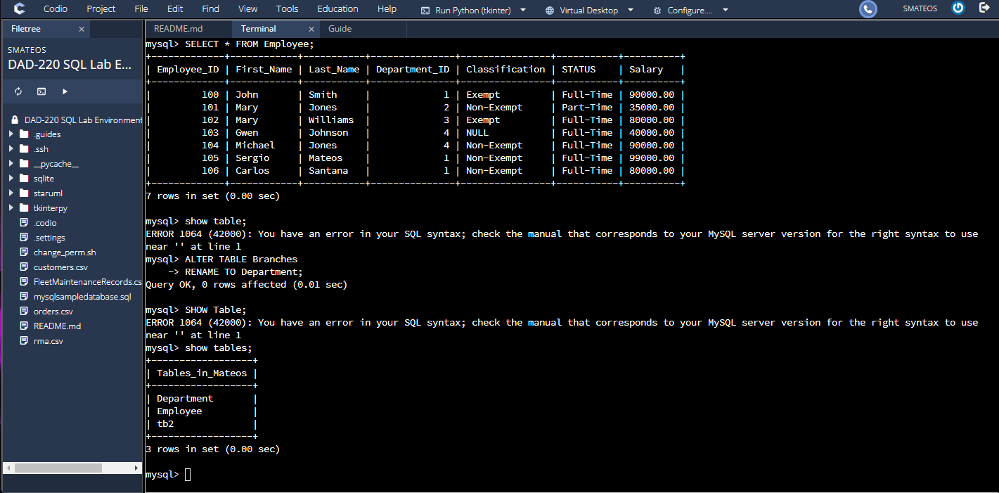Rename the “Branches” table to “Department.”

1. 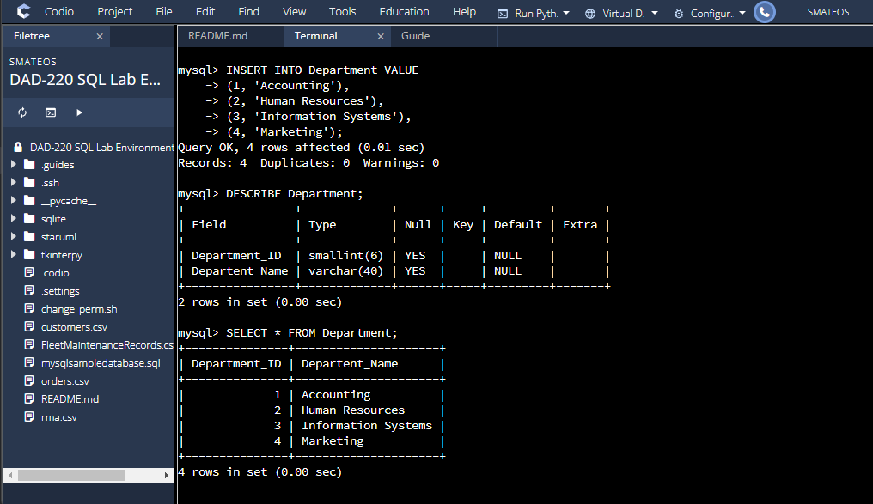Insert fields to the Department table.
2. Joins between the Department and Employee tables and show results.

* 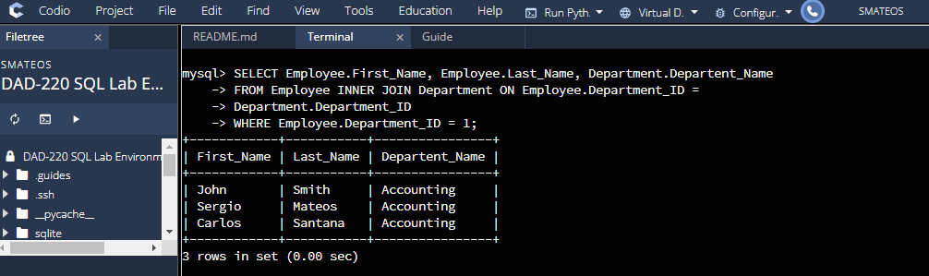Accounting ID 1
* A screenshot of a computer

  Description automatically generatedHuman Resources ID 2
* A screenshot of a computer

  Description automatically generatedInformation Systems ID 3
* A screenshot of a computer

  Description automatically generatedMarketing ID 4

1. Graphical user interface, text

   Description automatically generatedPopulate the Employee table with new employees.
2. Perform a join across the Employee and Department Tables.

* A screenshot of a computer

  Description automatically generatedAccounting ID 1
* A screenshot of a computer

  Description automatically generatedHuman Resources ID 2
* Information Systems ID 3

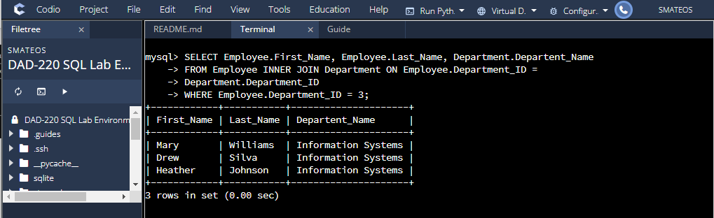

* A screenshot of a computer

  Description automatically generatedMarketing ID 4

1. 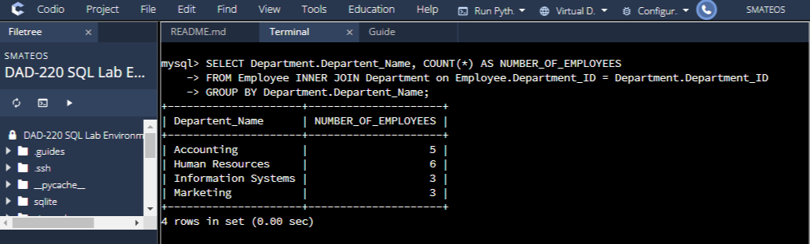Identify the resultant outputs.
2. 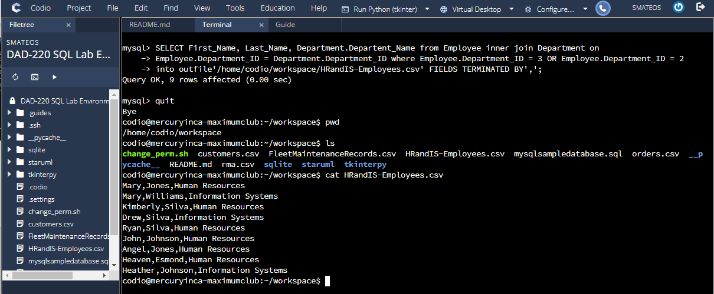Create a CSV file.
3. Reflection

* Process:
  + The inner join was used by selecting the rows from both tables (left and right) of the inner join clause itself. Then I select all the left join which I limited matches to the rows containing the Department_ID of 2 using the where clause. Then I used right join which I request all the Information System rows from the right table and all the matching rows from the Employee table. Finally, I used the full join to test the results.
  + The joins were connected via Department_ID that share using the ON clause.
* File creation and extraction
  + There were 9 records in the CVS file.
  + First select a statement to request information wanted to the present. I used inner join to all matching rows from the Employee table. The on clause hooked the two tables via the Department_ID column.